[**Banking Account System Management**](https://cppforschool.com/project/banking-system-project.html)

C++ Project for FT SD M 13

Name: Hong Rattanak

Description: This C++ programs on BANKING SYSTEM has account class with data members like account number, name, deposit/withdraw amount and type of account. Customer data is stored in a binary file. A customer can deposit and withdraw amount in his account. User can create, modify and delete account.

1. Project modules and features
2. Bank Account Management

* Create Bank Account
* View all bank account
* Update a specific bank account
* Delete a specific bank account
* Find a specific bank account
* Sort bank account
* Deposit Bank Account
* Withdraw Bank Account
* Save Bank Data

1. Project Design
2. Logical Design

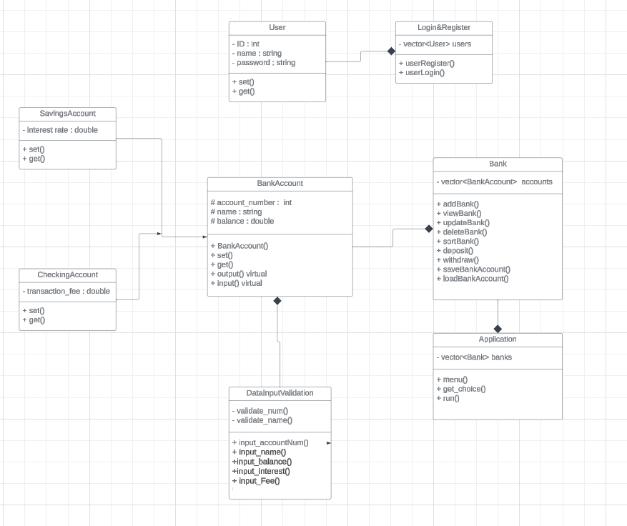

1. Physical design

. UI design

When you run the program, it will first show a user menu below:

==========Welcome to Bank Management==========

1. Login
2. Register
3. Exit

Enter your choice (1-3) 🡪 2

Enter username: LEON

Enter password: 123

“User created”

==========Welcome to Bank Management==========

1. Login
2. Register
3. Exit

Enter your choice (1-3) 🡪 1

Enter username: lina

Invalid username…

==========Welcome to Bank Management==========

1. Login
2. Register
3. Exit

Enter your choice (1-3) 🡪 1

Enter username: LEON

Enter password: 123

WELCOME Dara

==========Bank Management Menu==========

1. Create Bank Account
2. View all bank account
3. Update a specific bank account
4. Delete a specific bank account
5. Find a specific bank account
6. Sort bank account
7. Deposit from specific bank account
8. Withdraw from specific bank account
9. Save Bank Data
10. Log out

Enter your choice (1-11) 🡪 1

1. CheckingAccount
2. SavingAccount

Select which account to create (1-2) 🡪 1

Enter ID: 1

Enter name: Blop

Enter balance: 53

Enter transaction fee: 2.5

Do you want to continue? (y/n) 🡪 y

Enter ID: 2

Enter name: Mary

Enter balance: 42

Enter transaction fee: 1

Do you want to continue? (y/n) 🡪 n

WELCOME LEON

==========Bank Management Menu==========

1. Create Bank Account
2. View all bank account
3. Update a specific bank account
4. Delete a specific bank account
5. Find a specific bank account
6. Sort bank account
7. Deposit from specific bank account
8. Withdraw from specific bank account
9. Save Bank Data
10. Log out

Enter your choice (1-11) 🡪 2

SavingAccount:

ID Name Balance Interest rate

1 Blop 53 2.5

CheckingAccount:

ID Name Balance Transaction fee

2 Mary 42 1

Press any key to continue…..

WELCOME LEON

==========Bank Management Menu==========

1. Create Bank Account
2. View all bank account
3. Update a specific bank account
4. Delete a specific bank account
5. Find a specific bank account
6. Sort bank account
7. Deposit from specific bank account
8. Withdraw from specific bank account
9. Save Bank Data
10. Log out

Enter your choice (1-11) 🡪 3

SavingAccount:

ID Name Balance Interest rate

1 Blop 53 2.5

Press any key to continue….

WELCOME LEON

==========Bank Management Menu==========

1. Create Bank Account
2. View all bank account
3. Update a specific bank account
4. Delete a specific bank account
5. Find a specific bank account
6. Sort bank account
7. Deposit from specific bank account
8. Withdraw from specific bank account
9. Save Bank Data
10. Log out

Enter your choice (1-11) 🡪 4

1. ID
2. Name
3. Back to main menu

Select which one to find (1-3) 🡪 1

Enter ID: 1

SavingAccount:

ID Name Balance Interest rate

1. Blop 53 2.5
2. ID
3. Name
4. Transaction/Interest
5. Back

Enter your choice (1-4) 🡪 3

Enter new interest rate: 12

Change made successfully

SavingAccount:

ID Name Balance Interest rate

1 Blop 53 12

Do you want to continue? (y/n) 🡪 n

WELCOME LEON

==========Bank Management Menu==========

1. Create Bank Account
2. View all bank account
3. Update a specific bank account
4. Delete a specific bank account
5. Find a specific bank account
6. Sort bank account
7. Deposit from specific bank account
8. Withdraw from specific bank account
9. Save Bank Data
10. Log out

Enter your choice (1-11) 🡪 4

1. ID
2. Name
3. Back to main menu

Select which one to find (1-3) 🡪 1

Enter ID: 1

SavingAccount:

ID Name Balance Interest rate

1 Blop 53 12

Confirm Deletion? (y/n) 🡪 y

Deletion Success

Do you want to continue? (y/n) 🡪 n

WELCOME LEON

==========Bank Management Menu==========

1. Create Bank Account
2. View all bank account
3. Update a specific bank account
4. Delete a specific bank account
5. Find a specific bank account
6. Sort bank account
7. Deposit from specific bank account
8. Withdraw from specific bank account
9. Save Bank Data
10. Log out

Enter your choice (1-11) 🡪 6

1. Sort by ID
2. Sort by name
3. Back to main menu

How would you sort by? (1-3) 🡪 2

1. Sort by ascending
2. Sort by descending
3. Back

Enter choice(1-3)-> 1

Sorting. . . . . .

Sorted Successfully

Do you want to continue? (y/n) 🡪 n

WELCOME LEON

==========Bank Management Menu==========

1. Create Bank Account
2. View all bank account
3. Update a specific bank account
4. Delete a specific bank account
5. Find a specific bank account
6. Sort bank account
7. Deposit from specific bank account
8. Withdraw from specific bank account
9. Save Bank Data
10. Log out

Enter your choice (1-11) 🡪 8

1. ID
2. Name
3. Back to main menu

Select which one to find (1-3) 🡪 1

Enter ID: 2

ID Name Balance Trans/Inter.

2 Mary 42 1

Type in the amount you want to deposit : 204

Deposit successfully

Do you want to continue? (y/n) 🡪n

WELCOME LEON

==========Bank Management Menu==========

1. Create Bank Account
2. View all bank account
3. Update a specific bank account
4. Delete a specific bank account
5. Find a specific bank account
6. Sort bank account
7. Deposit from specific bank account
8. Withdraw from specific bank account
9. Save Bank Data
10. Log out

Enter your choice (1-11) 🡪 9

1. ID
2. Name
3. Back to main menu

Select which one to find (1-3) 🡪 1

Enter ID: 2

ID Name Balance Trans/Inter.

2 Mary 246 12

Type in the amount to withdraw: 2048

Insufficient balance

Type in the amount to withdraw: 100

Withdraw successfully

Do you want to continue? (y/n) 🡪 n

WELCOME LEON

==========Bank Management Menu==========

1. Create Bank Account
2. View all bank account
3. Update a specific bank account
4. Delete a specific bank account
5. Find a specific bank account
6. Sort bank account
7. Deposit from specific bank account
8. Withdraw from specific bank account
9. Save Bank Data
10. Log out

Enter your choice (1-11) 🡪 10

Bank data saved successfully

Press any key to continue……

WELCOME LEON

==========Bank Management Menu==========

1. Create Bank Account
2. View all bank account
3. Update a specific bank account
4. Delete a specific bank account
5. Find a specific bank account
6. Sort bank account
7. Deposit from specific bank account
8. Withdraw from specific bank account
9. Save Bank Data
10. Log out

Enter your choice (1-11) 🡪 11

==========User Management Menu==========

1. Register a new user
2. Update a specific user
3. Search for a specific user
4. Delete a specific user
5. User Authentication
6. Exit

Enter your choice (0-5) 🡪 0

Exiting program….

END OF PROGRAM